# CREATE CHATBOT IN PYTHON

911721104048:B.Kabileshwaran

**Phase 2 Submission Document**

**Project :** Creating chatbot

**Introduction**

* Briefly introduce the concept of pre-trained language models and their significance in natural language processing.
* Highlight the growing demand for chatbots and conversational AI systems.
* Set the context for how pre-trained language models can revolutionize chatbot development.

**content for Project Phase 2**

consider exploring advanced techniques like using pre-trained language models (e.g., GPT-3) to enhance the quality of responses.

**Data Source**

A good data source for chatbot in Python should exhibit the characteristics like relevance, completeness, coverage, quality and accessibility.

Dataset link: <https://www.kaggle.com/datasets/grafstor/simple-dialogs-for-chatbot>



**Understanding Pre-trained Language Models**

* Explain the concept of pre-trained language models, which are neural network-based models pre-trained on vast amounts of text data.
* Mention popular models like GPT-3, BERT, RoBERTa, and their contributions to NLP.

Benefits of Using Pre-trained Language Models:

* Improved natural language understanding.
* Efficient transfer learning for specific tasks.
* Enhanced response generation and conversational quality.

**Implementation Steps**

* Choosing the Right Pre-trained Model
* Fine-tuning for Chatbot Tasks
* Integration with Chatbot Infrastructure

**Enhancing Chatbot Capabilities**

Natural Language Understanding (NLU)

how pre-trained models improve NLU:

* Intent recognition.
* Named entity recognition.
* User input preprocessing.

Response Generation:

Highlight the capability to handle user queries, maintain context, and provide informative answers.

**Evaluation and Optimization**

Performance Evaluation:

Describe methods for evaluating chatbot performance, including:

* User testing and feedback.
* Automated metrics for response quality.
* Benchmarking against existing chatbots.

Continuous Improvement

* Emphasize the importance of ongoing model maintenance and optimization.
* Mention techniques like reinforcement learning for chatbot improvement.

**Program:**

**chatbot in python**

**IN[1]:**

import tensorflow as tf

import numpy as np

import pandas as pd

import matplotlib.pyplot as plt

import seaborn as sns

from tensorflow.keras.layers import TextVectorization

import re,string

from tensorflow.keras.layers import LSTM , Dense , Embedding , Dropout ,LayerNormalization

**IN[2]:**

df=pd.read_csv(' [/kaggle.com/datasets/grafstor/simple-dialogs-for-chatbot](https://www.kaggle.com/datasets/grafstor/simple-dialogs-for-chatbot) dialogs.txt',sep='\t',names=['question','answer'])

print(f'Dataframe size: {len(df)}')

df.head()

**OU[2]:**



**Data Preprocessing**

**Data Visualization**

**IN[3]:**

df['question tokens']=df['question'].apply(lambda x:len(x.split()))

df['answer tokens']=df['answer'].apply(lambda x:len(x.split()))

plt.style.use('fivethirtyeight')

fig,ax=plt.subplots(nrows=1,ncols=2,figsize=(20,5))

sns.set_palette('Set2')

sns.histplot(x=df['question tokens'],data=df,kde=True,ax=ax[0])

sns.histplot(x=df['answer tokens'],data=df,kde=True,ax=ax[1])

sns.jointplot(x='question tokens',y='answer tokens',data=df,kind='kde',fill=True,cmap='YlGnBu')

plt.show()

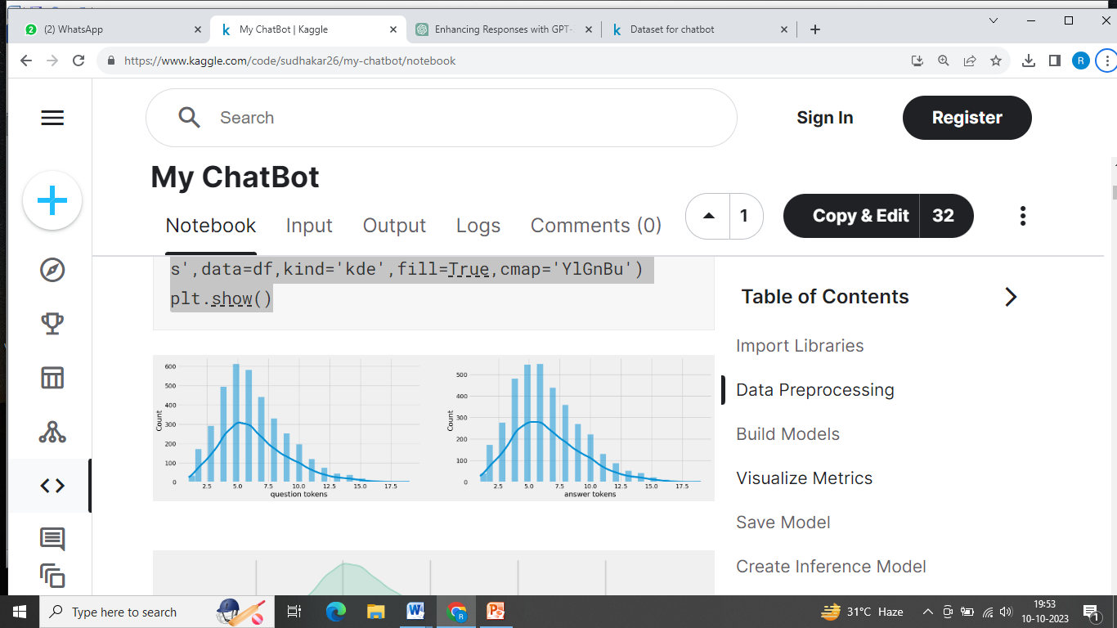

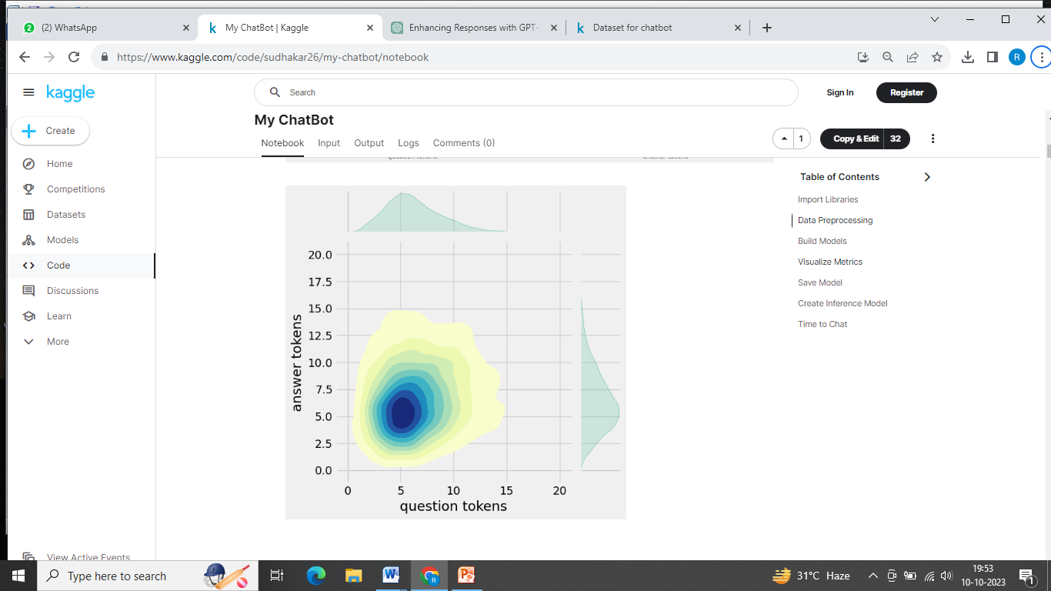

**Text Cleaning**

**IN[4]:**

def clean_text(text):

text=re.sub('-',' ',text.lower())

text=re.sub('[.]',' . ',text)

text=re.sub('[1]',' 1 ',text)

text=re.sub('[2]',' 2 ',text)

text=re.sub('[3]',' 3 ',text)

text=re.sub('[4]',' 4 ',text)

text=re.sub('[5]',' 5 ',text)

text=re.sub('[6]',' 6 ',text)

text=re.sub('[7]',' 7 ',text)

text=re.sub('[8]',' 8 ',text)

text=re.sub('[9]',' 9 ',text)

text=re.sub('[0]',' 0 ',text)

text=re.sub('[,]',' , ',text)

text=re.sub('[?]',' ? ',text)

text=re.sub('[!]',' ! ',text)

text=re.sub('[$]',' $ ',text)

text=re.sub('[&]',' & ',text)

text=re.sub('[/]',' / ',text)

text=re.sub('[:]',' : ',text)

text=re.sub('[;]',' ; ',text)

text=re.sub('[*]',' * ',text)

text=re.sub('[\']',' \' ',text)

text=re.sub('[\"]',' \" ',text)

text=re.sub('\t',' ',text)

return text

df.drop(columns=['answer tokens','question tokens'],axis=1,inplace=True)

df['encoder_inputs']=df['question'].apply(clean_text)

df['decoder_targets']=df['answer'].apply(clean_text)+' <end>'

df['decoder_inputs']='<start> '+df['answer'].apply(clean_text)+' <end>'

df.head(10)

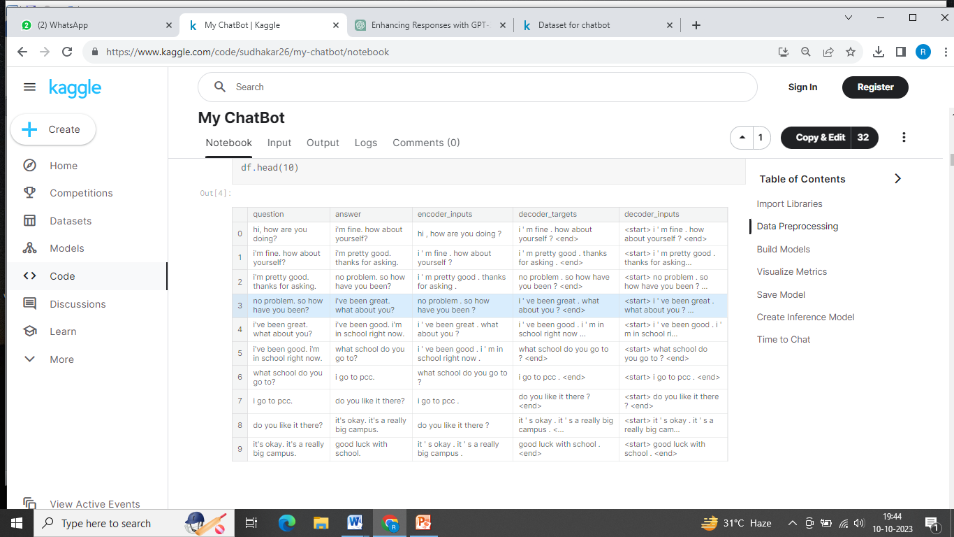

**IN[5]:**

df['encoder input tokens']=df['encoder_inputs'].apply(lambda x:len(x.split()))

df['decoder input tokens']=df['decoder_inputs'].apply(lambda x:len(x.split()))

df['decoder target tokens']=df['decoder_targets'].apply(lambda x:len(x.split()))

plt.style.use('fivethirtyeight')

fig,ax=plt.subplots(nrows=1,ncols=3,figsize=(20,5))

sns.set_palette('Set2')

sns.histplot(x=df['encoder input tokens'],data=df,kde=True,ax=ax[0])

sns.histplot(x=df['decoder input tokens'],data=df,kde=True,ax=ax[1])

sns.histplot(x=df['decoder target tokens'],data=df,kde=True,ax=ax[2])

sns.jointplot(x='encoder input tokens',y='decoder target tokens',data=df,kind='kde',fill=True,cmap='YlGnBu')

plt.show()

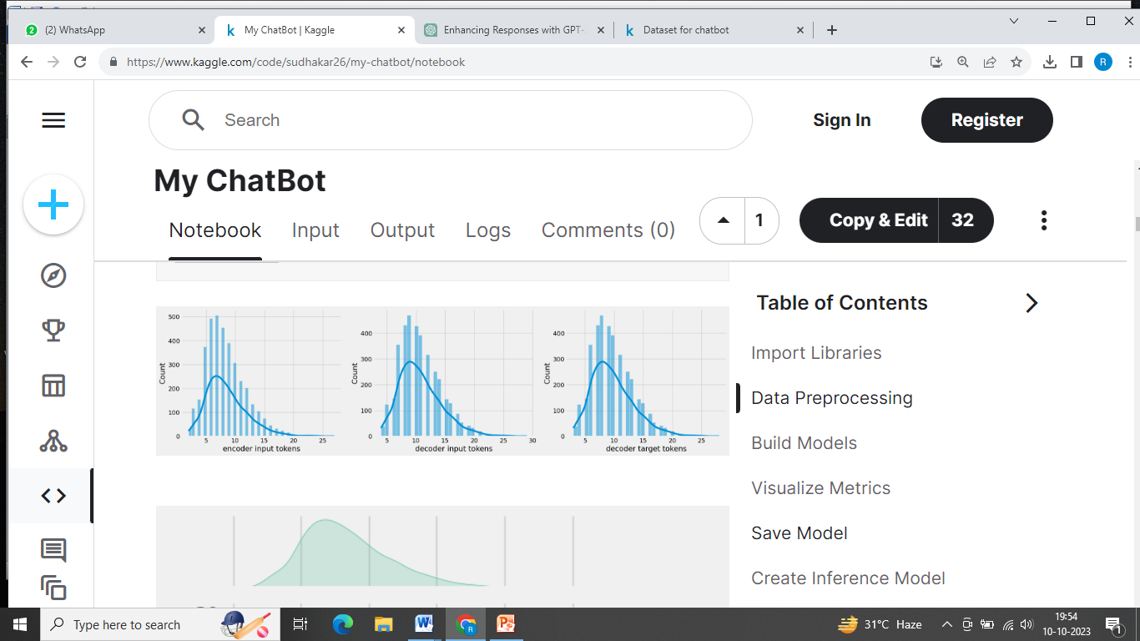

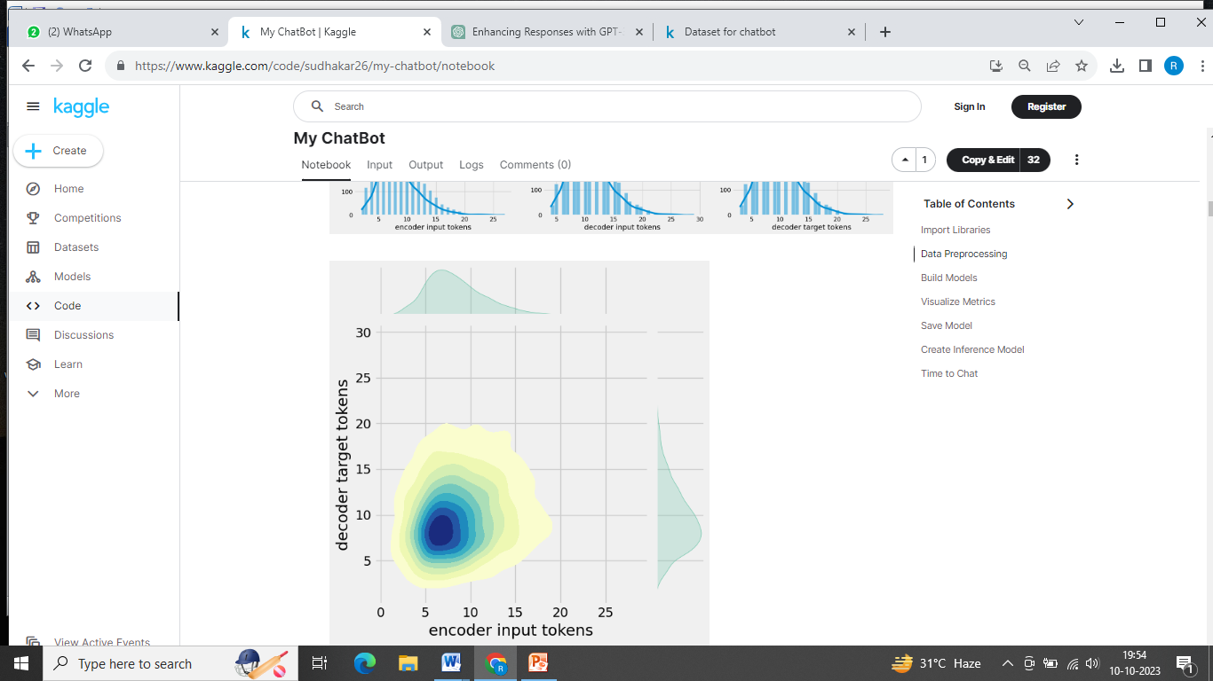

**IN[6]:**

print(f"After preprocessing: {' '.join(df[df['encoder input tokens'].max()==df['encoder input tokens']]['encoder_inputs'].values.tolist())}")

print(f"Max encoder input length: {df['encoder input tokens'].max()}")

print(f"Max decoder input length: {df['decoder input tokens'].max()}")

print(f"Max decoder target length: {df['decoder target tokens'].max()}")

df.drop(columns=['question','answer','encoder input tokens','decoder input tokens','decoder target tokens'],axis=1,inplace=True)

params={

"vocab_size":2500,

"max_sequence_length":30,

"learning_rate":0.008,

"batch_size":149,

"lstm_cells":256,

"embedding_dim":256,

"buffer_size":10000

}

learning_rate=params['learning_rate']

batch_size=params['batch_size']

embedding_dim=params['embedding_dim']

lstm_cells=params['lstm_cells']

vocab_size=params['vocab_size']

buffer_size=params['buffer_size']

max_sequence_length=params['max_sequence_length']

df.head(10)

**OU[6]:**



**Tokenization**

**IN[7]:**

vectorize_layer=TextVectorization(

max_tokens=vocab_size,

standardize=None,

output_mode='int',

output_sequence_length=max_sequence_length

)

vectorize_layer.adapt(df['encoder_inputs']+' '+df['decoder_targets']+' <start> <end>')

vocab_size=len(vectorize_layer.get_vocabulary())

print(f'Vocab size: {len(vectorize_layer.get_vocabulary())}')

print(f'{vectorize_layer.get_vocabulary()[:12]}')

**IN[8]:**

def sequences2ids(sequence):

return vectorize_layer(sequence)

def ids2sequences(ids):

decode=''

if type(ids)==int:

ids=[ids]

for id in ids:

decode+=vectorize_layer.get_vocabulary()[id]+' '

return decode

x=sequences2ids(df['encoder_inputs'])

yd=sequences2ids(df['decoder_inputs'])

y=sequences2ids(df['decoder_targets'])

print(f'Question sentence: hi , how are you ?')

print(f'Question to tokens: {sequences2ids("hi , how are you ?")[:10]}')

print(f'Encoder input shape: {x.shape}')

print(f'Decoder input shape: {yd.shape}')

print(f'Decoder target shape: {y.shape}')

**IN[9]:**

print(f'Encoder input: {x[0][:12]} ...')

print(f'Decoder input: {yd[0][:12]} ...') # shifted by one time step of the target as input to decoder is the output of the previous timestep

print(f'Decoder target: {y[0][:12]} ...')

**IN[10]:**

data=tf.data.Dataset.from_tensor_slices((x,yd,y))

data=data.shuffle(buffer_size)

train_data=data.take(int(.9*len(data)))

train_data=train_data.cache()

train_data=train_data.shuffle(buffer_size)

train_data=train_data.batch(batch_size)

train_data=train_data.prefetch(tf.data.AUTOTUNE)

train_data_iterator=train_data.as_numpy_iterator()

val_data=data.skip(int(.9*len(data))).take(int(.1*len(data)))

val_data=val_data.batch(batch_size)

val_data=val_data.prefetch(tf.data.AUTOTUNE)

_=train_data_iterator.next()

print(f'Number of train batches: {len(train_data)}')

print(f'Number of training data: {len(train_data)*batch_size}')

print(f'Number of validation batches: {len(val_data)}')

print(f'Number of validation data: {len(val_data)*batch_size}')

print(f'Encoder Input shape (with batches): {_[0].shape}')

print(f'Decoder Input shape (with batches): {_[1].shape}')

print(f'Target Output shape (with batches): {_[2].shape}')

**Build Models**

**Build Encoder**

**IN[11]:**

class Encoder(tf.keras.models.Model):

def __init__(self,units,embedding_dim,vocab_size,*args,**kwargs) -> None:

super().__init__(*args,**kwargs)

self.units=units

self.vocab_size=vocab_size

self.embedding_dim=embedding_dim

self.embedding=Embedding(

vocab_size,

embedding_dim,

name='encoder_embedding',

mask_zero=True,

embeddings_initializer=tf.keras.initializers.GlorotNormal()

)

self.normalize=LayerNormalization()

self.lstm=LSTM(

units,

dropout=.4,

return_state=True,

return_sequences=True,

name='encoder_lstm',

kernel_initializer=tf.keras.initializers.GlorotNormal()

)

def call(self,encoder_inputs):

self.inputs=encoder_inputs

x=self.embedding(encoder_inputs)

x=self.normalize(x)

x=Dropout(.4)(x)

encoder_outputs,encoder_state_h,encoder_state_c=self.lstm(x)

self.outputs=[encoder_state_h,encoder_state_c]

return encoder_state_h,encoder_state_c

encoder=Encoder(lstm_cells,embedding_dim,vocab_size,name='encoder')

encoder.call(_[0])

**OU[11]:**

(<tf.Tensor: shape=(149, 256), dtype=float32, numpy=

array([[ 0.16966951, -0.10419625, -0.12700348, ..., -0.12251794,

0.10568858, 0.14841646],

[ 0.08443093, 0.08849293, -0.09065959, ..., -0.00959182,

0.10152507, -0.12077457],

[ 0.03628462, -0.02653611, -0.11506603, ..., -0.14669597,

0.10292757, 0.13625325],

...,

[-0.14210635, -0.12942064, -0.03288083, ..., 0.0568463 ,

-0.02598592, -0.22455114],

[ 0.20819993, 0.01196991, -0.09635217, ..., -0.18782297,

0.10233591, 0.20114912],

[ 0.1164271 , -0.07769038, -0.06414707, ..., -0.06539135,

-0.05518465, 0.25142196]], dtype=float32)>,

<tf.Tensor: shape=(149, 256), dtype=float32, numpy=

array([[ 0.34589 , -0.30134732, -0.43572 , ..., -0.3102559 ,

0.34630865, 0.2613009 ],

[ 0.14154069, 0.17045322, -0.17749965, ..., -0.02712595,

0.17292541, -0.2922624 ],

[ 0.07106856, -0.0739173 , -0.3641197 , ..., -0.3794833 ,

0.36470377, 0.23766585],

...,

[-0.2582597 , -0.25323495, -0.06649272, ..., 0.16527973,

-0.04292646, -0.58768904],

[ 0.43155715, 0.03135502, -0.33463806, ..., -0.47625306,

0.33486888, 0.35035062],

[ 0.23173636, -0.20141824, -0.22034441, ..., -0.16035017,

-0.17478186, 0.48899865]], dtype=float32)>)

Build Encoder## Build Decoder

**IN[12]:**

class Decoder(tf.keras.models.Model):

def __init__(self,units,embedding_dim,vocab_size,*args,**kwargs) -> None:

super().__init__(*args,**kwargs)

self.units=units

self.embedding_dim=embedding_dim

self.vocab_size=vocab_size

self.embedding=Embedding(

vocab_size,

embedding_dim,

name='decoder_embedding',

mask_zero=True,

embeddings_initializer=tf.keras.initializers.HeNormal()

)

self.normalize=LayerNormalization()

self.lstm=LSTM(

units,

dropout=.4,

return_state=True,

return_sequences=True,

name='decoder_lstm',

kernel_initializer=tf.keras.initializers.HeNormal()

)

self.fc=Dense(

vocab_size,

activation='softmax',

name='decoder_dense',

kernel_initializer=tf.keras.initializers.HeNormal()

)

def call(self,decoder_inputs,encoder_states):

x=self.embedding(decoder_inputs)

x=self.normalize(x)

x=Dropout(.4)(x)

x,decoder_state_h,decoder_state_c=self.lstm(x,initial_state=encoder_states)

x=self.normalize(x)

x=Dropout(.4)(x)

return self.fc(x)

decoder=Decoder(lstm_cells,embedding_dim,vocab_size,name='decoder')

decoder(_[1][:1],encoder(_[0][:1]))

**OU[12]:**

<tf.Tensor: shape=(1, 30, 2443), dtype=float32, numpy=

array([[[3.4059247e-04, 5.7348556e-05, 2.1294907e-05, ...,

7.2067953e-05, 1.5453645e-03, 2.3599296e-04],

[1.4662130e-03, 8.0250365e-06, 5.4062020e-05, ...,

1.9187471e-05, 9.7244098e-05, 7.6433855e-05],

[9.6929165e-05, 2.7441782e-05, 1.3761305e-03, ...,

3.6009602e-05, 1.5537882e-04, 1.8397317e-04],

...,

[1.9002777e-03, 6.9266016e-04, 1.4346189e-04, ...,

1.9552530e-04, 1.7106640e-05, 1.0252406e-04],

[1.9002777e-03, 6.9266016e-04, 1.4346189e-04, ...,

1.9552530e-04, 1.7106640e-05, 1.0252406e-04],

[1.9002777e-03, 6.9266016e-04, 1.4346189e-04, ...,

1.9552530e-04, 1.7106640e-05, 1.0252406e-04]]], dtype=float32)>

**Build Training Model**

**IN[13]:**

class ChatBotTrainer(tf.keras.models.Model):

def __init__(self,encoder,decoder,*args,**kwargs):

super().__init__(*args,**kwargs)

self.encoder=encoder

self.decoder=decoder

def loss_fn(self,y_true,y_pred):

loss=self.loss(y_true,y_pred)

mask=tf.math.logical_not(tf.math.equal(y_true,0))

mask=tf.cast(mask,dtype=loss.dtype)

loss*=mask

return tf.reduce_mean(loss)

def accuracy_fn(self,y_true,y_pred):

pred_values = tf.cast(tf.argmax(y_pred, axis=-1), dtype='int64')

correct = tf.cast(tf.equal(y_true, pred_values), dtype='float64')

mask = tf.cast(tf.greater(y_true, 0), dtype='float64')

n_correct = tf.keras.backend.sum(mask * correct)

n_total = tf.keras.backend.sum(mask)

return n_correct / n_total

def call(self,inputs):

encoder_inputs,decoder_inputs=inputs

encoder_states=self.encoder(encoder_inputs)

return self.decoder(decoder_inputs,encoder_states)

def train_step(self,batch):

encoder_inputs,decoder_inputs,y=batch

with tf.GradientTape() as tape:

encoder_states=self.encoder(encoder_inputs,training=True)

y_pred=self.decoder(decoder_inputs,encoder_states,training=True)

loss=self.loss_fn(y,y_pred)

acc=self.accuracy_fn(y,y_pred)

variables=self.encoder.trainable_variables+self.decoder.trainable_variables

grads=tape.gradient(loss,variables)

self.optimizer.apply_gradients(zip(grads,variables))

metrics={'loss':loss,'accuracy':acc}

return metrics

def test_step(self,batch):

encoder_inputs,decoder_inputs,y=batch

encoder_states=self.encoder(encoder_inputs,training=True)

y_pred=self.decoder(decoder_inputs,encoder_states,training=True)

loss=self.loss_fn(y,y_pred)

acc=self.accuracy_fn(y,y_pred)

metrics={'loss':loss,'accuracy':acc}

return metrics

**IN[14]:**

model=ChatBotTrainer(encoder,decoder,name='chatbot_trainer')

model.compile(

loss=tf.keras.losses.SparseCategoricalCrossentropy(),

optimizer=tf.keras.optimizers.Adam(learning_rate=learning_rate),

weighted_metrics=['loss','accuracy']

)

model(_[:2])

**OU[14]:**

<tf.Tensor: shape=(149, 30, 2443), dtype=float32, numpy=

array([[[3.40592262e-04, 5.73484940e-05, 2.12948853e-05, ...,

7.20679745e-05, 1.54536311e-03, 2.35993255e-04],

[1.46621116e-03, 8.02504110e-06, 5.40619949e-05, ...,

1.91874733e-05, 9.72440175e-05, 7.64339056e-05],

[9.69291723e-05, 2.74417835e-05, 1.37613132e-03, ...,

3.60095728e-05, 1.55378671e-04, 1.83973272e-04],

...,

[1.90027885e-03, 6.92659756e-04, 1.43461803e-04, ...,

1.95525470e-04, 1.71066222e-05, 1.02524005e-04],

[1.90027885e-03, 6.92659756e-04, 1.43461803e-04, ...,

1.95525470e-04, 1.71066222e-05, 1.02524005e-04],

[1.90027885e-03, 6.92659756e-04, 1.43461803e-04, ...,

1.95525470e-04, 1.71066222e-05, 1.02524005e-04]],

[[9.24730921e-05, 3.46553512e-04, 2.07866033e-05, ...,

3.65934626e-04, 7.63039337e-04, 5.52638434e-04],

[8.46863186e-05, 3.65541164e-05, 2.54740953e-05, ...,

7.12379551e-05, 3.62201303e-04, 4.16714087e-04],

[2.30146630e-04, 3.91469621e-06, 2.72463716e-04, ...,

9.26126595e-05, 1.03836363e-04, 1.40792166e-04],

...,

[6.84961735e-04, 9.07644513e-04, 2.86691647e-04, ...,

3.87946144e-04, 6.09236558e-05, 1.12995331e-05],

[6.84961735e-04, 9.07644513e-04, 2.86691647e-04, ...,

3.87946144e-04, 6.09236558e-05, 1.12995331e-05],

[6.84961735e-04, 9.07644513e-04, 2.86691647e-04, ...,

3.87946144e-04, 6.09236558e-05, 1.12995322e-05]],

[[1.19036995e-03, 8.10516722e-05, 2.42324077e-05, ...,

4.99442758e-05, 6.67208573e-04, 9.55566764e-04],

[1.53046989e-04, 9.76863957e-05, 4.96972689e-06, ...,

3.24743196e-05, 2.12563842e-04, 1.18708890e-03],

[9.40205529e-04, 1.80782794e-04, 7.26205144e-06, ...,

1.96355060e-04, 8.16940737e-05, 1.38416886e-03],

...,

[3.52622545e-03, 1.26781175e-03, 1.02695449e-04, ...,

2.35450850e-03, 3.25187625e-06, 9.46984728e-05],

[3.52622545e-03, 1.26781175e-03, 1.02695449e-04, ...,

2.35450850e-03, 3.25187625e-06, 9.46984728e-05],

[3.52622545e-03, 1.26781175e-03, 1.02695449e-04, ...,

2.35450850e-03, 3.25187625e-06, 9.46984728e-05]],

...,

[[9.03617911e-05, 1.57651404e-04, 1.02747028e-04, ...,

2.20922651e-04, 3.61504179e-04, 2.32456136e-03],

[1.55469708e-04, 1.53608169e-04, 1.14945491e-04, ...,

1.88878359e-04, 5.11967926e-04, 5.13108505e-04],

[8.27641197e-05, 2.83437112e-05, 6.29429938e-04, ...,

2.15980137e-04, 3.02832137e-04, 1.77760507e-04],

...,

[2.41102395e-03, 1.29279669e-03, 9.11735406e-05, ...,

4.06600971e-04, 7.58682154e-06, 6.05909081e-05],

[2.41102395e-03, 1.29279669e-03, 9.11735406e-05, ...,

4.06600971e-04, 7.58682154e-06, 6.05909081e-05],

[2.41102395e-03, 1.29279669e-03, 9.11735406e-05, ...,

4.06600971e-04, 7.58682154e-06, 6.05909081e-05]],

[[3.99837241e-04, 2.36026899e-05, 6.89777007e-05, ...,

5.94239136e-05, 4.32556757e-04, 4.60232928e-04],

[3.88111075e-04, 8.31133584e-05, 1.11861555e-04, ...,

3.03280340e-05, 2.54765386e-04, 2.82170397e-04],

[2.12516752e-03, 7.19837190e-05, 1.88700986e-04, ...,

1.86366087e-04, 7.02239413e-05, 2.54370330e-04],

...,

[4.56329063e-03, 2.23812275e-03, 2.37343236e-04, ...,

2.64523784e-04, 4.05454011e-05, 1.55662783e-04],

[4.56329063e-03, 2.23812275e-03, 2.37343236e-04, ...,

2.64523784e-04, 4.05454011e-05, 1.55662783e-04],

[4.56329063e-03, 2.23812275e-03, 2.37343236e-04, ...,

2.64523784e-04, 4.05454011e-05, 1.55662783e-04]],

[[3.24600202e-04, 9.31067043e-05, 4.60048941e-05, ...,

6.66230699e-05, 5.76460850e-04, 1.52416309e-04],

[7.51478728e-05, 7.63997741e-05, 2.09082973e-05, ...,

2.55555002e-04, 2.28998848e-04, 4.37303359e-04],

[1.03114333e-04, 1.55743372e-04, 9.97955431e-06, ...,

1.12485175e-03, 4.80950950e-03, 6.83143327e-04],

...,

[5.20280097e-03, 3.23211338e-04, 2.47709468e-05, ...,

3.07609705e-04, 6.09844255e-06, 8.61325825e-05],

[5.20280097e-03, 3.23211338e-04, 2.47709468e-05, ...,

3.07609705e-04, 6.09844255e-06, 8.61325825e-05],

[5.20280097e-03, 3.23211338e-04, 2.47709468e-05, ...,

3.07609705e-04, 6.09844255e-06, 8.61325825e-05]]], dtype=float32)>

Train Model

**IN[15]:**

history=model.fit(

train_data,

epochs=100,

validation_data=val_data,

callbacks=[

tf.keras.callbacks.TensorBoard(log_dir='logs'),

tf.keras.callbacks.ModelCheckpoint('ckpt',verbose=1,save_best_only=True)

]

)

Epoch 1/100

23/23 [==============================] - ETA: 0s - loss: 1.6590 - accuracy: 0.2180

Epoch 1: val_loss improved from inf to 1.21875, saving model to ckpt

23/23 [==============================] - 68s 3s/step - loss: 1.6515 - accuracy: 0.2198 - val_loss: 1.2187 - val_accuracy: 0.3072

Epoch 2/100

23/23 [==============================] - ETA: 0s - loss: 1.2327 - accuracy: 0.3087

Epoch 2: val_loss improved from 1.21875 to 1.10877, saving model to ckpt

23/23 [==============================] - 53s 2s/step - loss: 1.2287 - accuracy: 0.3092 - val_loss: 1.1088 - val_accuracy: 0.3415

Epoch 3/100

23/23 [==============================] - ETA: 0s - loss: 1.1008 - accuracy: 0.3368

Epoch 3: val_loss did not improve from 1.10877

23/23 [==============================] - 22s 973ms/step - loss: 1.0984 - accuracy: 0.3370 - val_loss: 1.1161 - val_accuracy: 0.3315

Epoch 4/100

23/23 [==============================] - ETA: 0s - loss: 1.0209 - accuracy: 0.3536

Epoch 4: val_loss improved from 1.10877 to 0.95189, saving model to ckpt

23/23 [==============================] - 53s 2s/step - loss: 1.0186 - accuracy: 0.3540 - val_loss: 0.9519 - val_accuracy: 0.3718

Epoch 5/100

23/23 [==============================] - ETA: 0s - loss: 0.9622 - accuracy: 0.3673

Epoch 5: val_loss did not improve from 0.95189

23/23 [==============================] - 23s 979ms/step - loss: 0.9672 - accuracy: 0.3670 - val_loss: 0.9642 - val_accuracy: 0.3666

Epoch 6/100

23/23 [==============================] - ETA: 0s - loss: 0.9159 - accuracy: 0.3801

Epoch 6: val_loss improved from 0.95189 to 0.94015, saving model to ckpt

23/23 [==============================] - 53s 2s/step - loss: 0.9182 - accuracy: 0.3796 - val_loss: 0.9401 - val_accuracy: 0.3598

Epoch 7/100

23/23 [==============================] - ETA: 0s - loss: 0.8737 - accuracy: 0.3908

Epoch 7: val_loss improved from 0.94015 to 0.83293, saving model to ckpt

23/23 [==============================] - 52s 2s/step - loss: 0.8746 - accuracy: 0.3900 - val_loss: 0.8329 - val_accuracy: 0.4180

Epoch 8/100

23/23 [==============================] - ETA: 0s - loss: 0.8389 - accuracy: 0.4013

Epoch 8: val_loss improved from 0.83293 to 0.77748, saving model to ckpt

23/23 [==============================] - 53s 2s/step - loss: 0.8395 - accuracy: 0.4013 - val_loss: 0.7775 - val_accuracy: 0.4305

Epoch 9/100

23/23 [==============================] - ETA: 0s - loss: 0.8148 - accuracy: 0.4094

Epoch 9: val_loss did not improve from 0.77748

23/23 [==============================] - 23s 983ms/step - loss: 0.8187 - accuracy: 0.4084 - val_loss: 0.8608 - val_accuracy: 0.3830

Epoch 10/100

23/23 [==============================] - ETA: 0s - loss: 0.7889 - accuracy: 0.4200

Epoch 10: val_loss improved from 0.77748 to 0.73131, saving model to ckpt

23/23 [==============================] - 53s 2s/step - loss: 0.7923 - accuracy: 0.4188 - val_loss: 0.7313 - val_accuracy: 0.4515

Epoch 11/100

23/23 [==============================] - ETA: 0s - loss: 0.7624 - accuracy: 0.4284

Epoch 11: val_loss did not improve from 0.73131

23/23 [==============================] - 22s 965ms/step - loss: 0.7615 - accuracy: 0.4282 - val_loss: 0.8036 - val_accuracy: 0.4472

Epoch 12/100

23/23 [==============================] - ETA: 0s - loss: 0.7433 - accuracy: 0.4361

Epoch 12: val_loss did not improve from 0.73131

23/23 [==============================] - 23s 984ms/step - loss: 0.7452 - accuracy: 0.4354 - val_loss: 0.7384 - val_accuracy: 0.4623

Epoch 13/100

23/23 [==============================] - ETA: 0s - loss: 0.7246 - accuracy: 0.4493

Epoch 13: val_loss did not improve from 0.73131

23/23 [==============================] - 23s 988ms/step - loss: 0.7281 - accuracy: 0.4488 - val_loss: 0.8017 - val_accuracy: 0.4449

Epoch 14/100

23/23 [==============================] - ETA: 0s - loss: 0.7080 - accuracy: 0.4513

Epoch 14: val_loss did not improve from 0.73131

23/23 [==============================] - 23s 995ms/step - loss: 0.7080 - accuracy: 0.4509 - val_loss: 0.7568 - val_accuracy: 0.4259

Epoch 15/100

23/23 [==============================] - ETA: 0s - loss: 0.6853 - accuracy: 0.4620

Epoch 15: val_loss did not improve from 0.73131

23/23 [==============================] - 22s 974ms/step - loss: 0.6826 - accuracy: 0.4616 - val_loss: 0.7376 - val_accuracy: 0.4502

Epoch 16/100

23/23 [==============================] - ETA: 0s - loss: 0.6731 - accuracy: 0.4673

Epoch 16: val_loss did not improve from 0.73131

23/23 [==============================] - 23s 983ms/step - loss: 0.6733 - accuracy: 0.4672 - val_loss: 0.7646 - val_accuracy: 0.4538

Epoch 17/100

23/23 [==============================] - ETA: 0s - loss: 0.6576 - accuracy: 0.4732

Epoch 17: val_loss improved from 0.73131 to 0.66131, saving model to ckpt

23/23 [==============================] - 52s 2s/step - loss: 0.6539 - accuracy: 0.4738 - val_loss: 0.6613 - val_accuracy: 0.4714

Epoch 18/100

23/23 [==============================] - ETA: 0s - loss: 0.6468 - accuracy: 0.4807

Epoch 18: val_loss improved from 0.66131 to 0.65303, saving model to ckpt

23/23 [==============================] - 53s 2s/step - loss: 0.6458 - accuracy: 0.4805 - val_loss: 0.6530 - val_accuracy: 0.4993

Epoch 19/100

23/23 [==============================] - ETA: 0s - loss: 0.6353 - accuracy: 0.4881

Epoch 19: val_loss did not improve from 0.65303

23/23 [==============================] - 23s 994ms/step - loss: 0.6357 - accuracy: 0.4876 - val_loss: 0.7331 - val_accuracy: 0.4677

Epoch 20/100

23/23 [==============================] - ETA: 0s - loss: 0.6194 - accuracy: 0.4968

Epoch 20: val_loss improved from 0.65303 to 0.55054, saving model to ckpt

23/23 [==============================] - 54s 2s/step - loss: 0.6188 - accuracy: 0.4967 - val_loss: 0.5505 - val_accuracy: 0.5221

Epoch 21/100

23/23 [==============================] - ETA: 0s - loss: 0.6160 - accuracy: 0.4978

Epoch 21: val_loss did not improve from 0.55054

23/23 [==============================] - 23s 987ms/step - loss: 0.6182 - accuracy: 0.4965 - val_loss: 0.6790 - val_accuracy: 0.4979

Epoch 22/100

23/23 [==============================] - ETA: 0s - loss: 0.6011 - accuracy: 0.5052

Epoch 22: val_loss did not improve from 0.55054

23/23 [==============================] - 23s 996ms/step - loss: 0.6011 - accuracy: 0.5051 - val_loss: 0.6221 - val_accuracy: 0.5277

Epoch 23/100

23/23 [==============================] - ETA: 0s - loss: 0.5950 - accuracy: 0.5079

Epoch 23: val_loss did not improve from 0.55054

23/23 [==============================] - 23s 987ms/step - loss: 0.5934 - accuracy: 0.5081 - val_loss: 0.6142 - val_accuracy: 0.5198

Epoch 24/100

23/23 [==============================] - ETA: 0s - loss: 0.5810 - accuracy: 0.5160

Epoch 24: val_loss did not improve from 0.55054

23/23 [==============================] - 22s 971ms/step - loss: 0.5803 - accuracy: 0.5170 - val_loss: 0.5759 - val_accuracy: 0.5137

Epoch 25/100

23/23 [==============================] - ETA: 0s - loss: 0.5716 - accuracy: 0.5227

Epoch 25: val_loss did not improve from 0.55054

23/23 [==============================] - 23s 986ms/step - loss: 0.5733 - accuracy: 0.5229 - val_loss: 0.6344 - val_accuracy: 0.5169

Epoch 26/100

23/23 [==============================] - ETA: 0s - loss: 0.5676 - accuracy: 0.5225

Epoch 26: val_loss did not improve from 0.55054

23/23 [==============================] - 22s 963ms/step - loss: 0.5708 - accuracy: 0.5210 - val_loss: 0.6254 - val_accuracy: 0.4882

Epoch 27/100

23/23 [==============================] - ETA: 0s - loss: 0.5616 - accuracy: 0.5291

Epoch 27: val_loss did not improve from 0.55054

23/23 [==============================] - 23s 988ms/step - loss: 0.5624 - accuracy: 0.5280 - val_loss: 0.6774 - val_accuracy: 0.5379

Epoch 28/100

23/23 [==============================] - ETA: 0s - loss: 0.5531 - accuracy: 0.5318

Epoch 28: val_loss did not improve from 0.55054

23/23 [==============================] - 22s 949ms/step - loss: 0.5543 - accuracy: 0.5310 - val_loss: 0.7284 - val_accuracy: 0.5302

Epoch 29/100

23/23 [==============================] - ETA: 0s - loss: 0.5398 - accuracy: 0.5389

Epoch 29: val_loss did not improve from 0.55054

23/23 [==============================] - 23s 1s/step - loss: 0.5391 - accuracy: 0.5398 - val_loss: 0.7385 - val_accuracy: 0.5193

Epoch 30/100

23/23 [==============================] - ETA: 0s - loss: 0.5375 - accuracy: 0.5416

Epoch 30: val_loss improved from 0.55054 to 0.50346, saving model to ckpt

23/23 [==============================] - 53s 2s/step - loss: 0.5384 - accuracy: 0.5417 - val_loss: 0.5035 - val_accuracy: 0.5411

Epoch 31/100

23/23 [==============================] - ETA: 0s - loss: 0.5270 - accuracy: 0.5481

Epoch 31: val_loss did not improve from 0.50346

23/23 [==============================] - 22s 958ms/step - loss: 0.5262 - accuracy: 0.5477 - val_loss: 0.5805 - val_accuracy: 0.5457

Epoch 32/100

23/23 [==============================] - ETA: 0s - loss: 0.5304 - accuracy: 0.5447

Epoch 32: val_loss did not improve from 0.50346

23/23 [==============================] - 22s 963ms/step - loss: 0.5329 - accuracy: 0.5435 - val_loss: 0.5374 - val_accuracy: 0.5725

Epoch 33/100

23/23 [==============================] - ETA: 0s - loss: 0.5196 - accuracy: 0.5520

Epoch 33: val_loss did not improve from 0.50346

23/23 [==============================] - 23s 975ms/step - loss: 0.5211 - accuracy: 0.5518 - val_loss: 0.6217 - val_accuracy: 0.5066

Epoch 34/100

23/23 [==============================] - ETA: 0s - loss: 0.5129 - accuracy: 0.5558

Epoch 34: val_loss did not improve from 0.50346

23/23 [==============================] - 23s 1000ms/step - loss: 0.5129 - accuracy: 0.5556 - val_loss: 0.6070 - val_accuracy: 0.5653

Epoch 35/100

23/23 [==============================] - ETA: 0s - loss: 0.5059 - accuracy: 0.5620

Epoch 35: val_loss did not improve from 0.50346

23/23 [==============================] - 22s 966ms/step - loss: 0.5081 - accuracy: 0.5614 - val_loss: 0.6153 - val_accuracy: 0.5452

Epoch 36/100

23/23 [==============================] - ETA: 0s - loss: 0.5037 - accuracy: 0.5619

Epoch 36: val_loss did not improve from 0.50346

23/23 [==============================] - 23s 980ms/step - loss: 0.5063 - accuracy: 0.5617 - val_loss: 0.5328 - val_accuracy: 0.5873

Epoch 37/100

23/23 [==============================] - ETA: 0s - loss: 0.4977 - accuracy: 0.5682

Epoch 37: val_loss did not improve from 0.50346

23/23 [==============================] - 22s 969ms/step - loss: 0.4980 - accuracy: 0.5682 - val_loss: 0.5976 - val_accuracy: 0.5693

Epoch 38/100

23/23 [==============================] - ETA: 0s - loss: 0.4939 - accuracy: 0.5704

Epoch 38: val_loss did not improve from 0.50346

23/23 [==============================] - 23s 993ms/step - loss: 0.4953 - accuracy: 0.5687 - val_loss: 0.5937 - val_accuracy: 0.5236

Epoch 39/100

23/23 [==============================] - ETA: 0s - loss: 0.4860 - accuracy: 0.5758

Epoch 39: val_loss did not improve from 0.50346

23/23 [==============================] - 23s 986ms/step - loss: 0.4868 - accuracy: 0.5746 - val_loss: 0.6155 - val_accuracy: 0.5457

Epoch 40/100

23/23 [==============================] - ETA: 0s - loss: 0.4809 - accuracy: 0.5778

Epoch 40: val_loss did not improve from 0.50346

23/23 [==============================] - 23s 1s/step - loss: 0.4821 - accuracy: 0.5760 - val_loss: 0.5046 - val_accuracy: 0.5662

Epoch 41/100

23/23 [==============================] - ETA: 0s - loss: 0.4781 - accuracy: 0.5817

Epoch 41: val_loss did not improve from 0.50346

23/23 [==============================] - 23s 990ms/step - loss: 0.4782 - accuracy: 0.5821 - val_loss: 0.5256 - val_accuracy: 0.5907

Epoch 42/100

23/23 [==============================] - ETA: 0s - loss: 0.4713 - accuracy: 0.5836

Epoch 42: val_loss did not improve from 0.50346

23/23 [==============================] - 23s 982ms/step - loss: 0.4729 - accuracy: 0.5824 - val_loss: 0.6387 - val_accuracy: 0.5456

Epoch 43/100

23/23 [==============================] - ETA: 0s - loss: 0.4641 - accuracy: 0.5904

Epoch 43: val_loss did not improve from 0.50346

23/23 [==============================] - 23s 1s/step - loss: 0.4627 - accuracy: 0.5908 - val_loss: 0.5668 - val_accuracy: 0.5741

Epoch 44/100

23/23 [==============================] - ETA: 0s - loss: 0.4608 - accuracy: 0.5921

Epoch 44: val_loss improved from 0.50346 to 0.49920, saving model to ckpt

23/23 [==============================] - 53s 2s/step - loss: 0.4618 - accuracy: 0.5920 - val_loss: 0.4992 - val_accuracy: 0.5768

Epoch 45/100

23/23 [==============================] - ETA: 0s - loss: 0.4592 - accuracy: 0.5902

Epoch 45: val_loss did not improve from 0.49920

23/23 [==============================] - 22s 970ms/step - loss: 0.4599 - accuracy: 0.5887 - val_loss: 0.5423 - val_accuracy: 0.5854

Epoch 46/100

23/23 [==============================] - ETA: 0s - loss: 0.4535 - accuracy: 0.5978

Epoch 46: val_loss improved from 0.49920 to 0.48429, saving model to ckpt

23/23 [==============================] - 53s 2s/step - loss: 0.4552 - accuracy: 0.5966 - val_loss: 0.4843 - val_accuracy: 0.6049

Epoch 47/100

23/23 [==============================] - ETA: 0s - loss: 0.4528 - accuracy: 0.5987

Epoch 47: val_loss improved from 0.48429 to 0.47868, saving model to ckpt

23/23 [==============================] - 54s 2s/step - loss: 0.4537 - accuracy: 0.5990 - val_loss: 0.4787 - val_accuracy: 0.5906

Epoch 48/100

23/23 [==============================] - ETA: 0s - loss: 0.4441 - accuracy: 0.6016

Epoch 48: val_loss did not improve from 0.47868

23/23 [==============================] - 23s 982ms/step - loss: 0.4439 - accuracy: 0.6025 - val_loss: 0.5746 - val_accuracy: 0.5542

Epoch 49/100

23/23 [==============================] - ETA: 0s - loss: 0.4436 - accuracy: 0.6041

Epoch 49: val_loss did not improve from 0.47868

23/23 [==============================] - 22s 951ms/step - loss: 0.4432 - accuracy: 0.6045 - val_loss: 0.5058 - val_accuracy: 0.5753

Epoch 50/100

23/23 [==============================] - ETA: 0s - loss: 0.4435 - accuracy: 0.6033

Epoch 50: val_loss did not improve from 0.47868

23/23 [==============================] - 22s 949ms/step - loss: 0.4441 - accuracy: 0.6043 - val_loss: 0.6037 - val_accuracy: 0.5473

Epoch 51/100

23/23 [==============================] - ETA: 0s - loss: 0.4382 - accuracy: 0.6069

Epoch 51: val_loss did not improve from 0.47868

23/23 [==============================] - 22s 957ms/step - loss: 0.4383 - accuracy: 0.6067 - val_loss: 0.5206 - val_accuracy: 0.6154

Epoch 52/100

23/23 [==============================] - ETA: 0s - loss: 0.4293 - accuracy: 0.6125

Epoch 52: val_loss did not improve from 0.47868

23/23 [==============================] - 23s 971ms/step - loss: 0.4284 - accuracy: 0.6123 - val_loss: 0.4997 - val_accuracy: 0.5840

Epoch 53/100

23/23 [==============================] - ETA: 0s - loss: 0.4309 - accuracy: 0.6109

Epoch 53: val_loss improved from 0.47868 to 0.42987, saving model to ckpt

23/23 [==============================] - 52s 2s/step - loss: 0.4317 - accuracy: 0.6094 - val_loss: 0.4299 - val_accuracy: 0.6062

Epoch 54/100

23/23 [==============================] - ETA: 0s - loss: 0.4292 - accuracy: 0.6120

Epoch 54: val_loss did not improve from 0.42987

23/23 [==============================] - 22s 980ms/step - loss: 0.4309 - accuracy: 0.6115 - val_loss: 0.6996 - val_accuracy: 0.5592

Epoch 55/100

23/23 [==============================] - ETA: 0s - loss: 0.4225 - accuracy: 0.6115

Epoch 55: val_loss did not improve from 0.42987

23/23 [==============================] - 22s 976ms/step - loss: 0.4224 - accuracy: 0.6102 - val_loss: 0.5500 - val_accuracy: 0.5769

Epoch 56/100

23/23 [==============================] - ETA: 0s - loss: 0.4220 - accuracy: 0.6180

Epoch 56: val_loss did not improve from 0.42987

23/23 [==============================] - 23s 995ms/step - loss: 0.4236 - accuracy: 0.6169 - val_loss: 0.5689 - val_accuracy: 0.5817

Epoch 57/100

23/23 [==============================] - ETA: 0s - loss: 0.4173 - accuracy: 0.6210

Epoch 57: val_loss did not improve from 0.42987

23/23 [==============================] - 22s 976ms/step - loss: 0.4161 - accuracy: 0.6217 - val_loss: 0.4614 - val_accuracy: 0.6048

Epoch 58/100

23/23 [==============================] - ETA: 0s - loss: 0.4183 - accuracy: 0.6198

Epoch 58: val_loss did not improve from 0.42987

23/23 [==============================] - 23s 1s/step - loss: 0.4183 - accuracy: 0.6201 - val_loss: 0.4372 - val_accuracy: 0.6067

Epoch 59/100

23/23 [==============================] - ETA: 0s - loss: 0.4120 - accuracy: 0.6251

Epoch 59: val_loss did not improve from 0.42987

23/23 [==============================] - 23s 994ms/step - loss: 0.4136 - accuracy: 0.6237 - val_loss: 0.6183 - val_accuracy: 0.5948

Epoch 60/100

23/23 [==============================] - ETA: 0s - loss: 0.4090 - accuracy: 0.6239

Epoch 60: val_loss did not improve from 0.42987

23/23 [==============================] - 23s 980ms/step - loss: 0.4101 - accuracy: 0.6225 - val_loss: 0.5042 - val_accuracy: 0.6161

Epoch 61/100

23/23 [==============================] - ETA: 0s - loss: 0.4051 - accuracy: 0.6314

Epoch 61: val_loss did not improve from 0.42987

23/23 [==============================] - 23s 1s/step - loss: 0.4077 - accuracy: 0.6296 - val_loss: 0.5100 - val_accuracy: 0.6128

Epoch 62/100

23/23 [==============================] - ETA: 0s - loss: 0.4016 - accuracy: 0.6326

Epoch 62: val_loss did not improve from 0.42987

23/23 [==============================] - 24s 1s/step - loss: 0.4029 - accuracy: 0.6322 - val_loss: 0.5295 - val_accuracy: 0.6005

Epoch 63/100

23/23 [==============================] - ETA: 0s - loss: 0.4049 - accuracy: 0.6323

Epoch 63: val_loss did not improve from 0.42987

23/23 [==============================] - 23s 981ms/step - loss: 0.4069 - accuracy: 0.6316 - val_loss: 0.5103 - val_accuracy: 0.6088

Epoch 64/100

23/23 [==============================] - ETA: 0s - loss: 0.3951 - accuracy: 0.6335

Epoch 64: val_loss did not improve from 0.42987

23/23 [==============================] - 22s 981ms/step - loss: 0.3943 - accuracy: 0.6341 - val_loss: 0.5366 - val_accuracy: 0.5869

Epoch 65/100

23/23 [==============================] - ETA: 0s - loss: 0.3967 - accuracy: 0.6344

Epoch 65: val_loss improved from 0.42987 to 0.40702, saving model to ckpt

23/23 [==============================] - 53s 2s/step - loss: 0.3972 - accuracy: 0.6352 - val_loss: 0.4070 - val_accuracy: 0.6452

Epoch 66/100

23/23 [==============================] - ETA: 0s - loss: 0.3942 - accuracy: 0.6351

Epoch 66: val_loss did not improve from 0.40702

23/23 [==============================] - 22s 961ms/step - loss: 0.3954 - accuracy: 0.6337 - val_loss: 0.4963 - val_accuracy: 0.6039

Epoch 67/100

23/23 [==============================] - ETA: 0s - loss: 0.3884 - accuracy: 0.6409

Epoch 67: val_loss did not improve from 0.40702

23/23 [==============================] - 22s 951ms/step - loss: 0.3879 - accuracy: 0.6424 - val_loss: 0.4651 - val_accuracy: 0.6276

Epoch 68/100

23/23 [==============================] - ETA: 0s - loss: 0.3876 - accuracy: 0.6398

Epoch 68: val_loss improved from 0.40702 to 0.38016, saving model to ckpt

23/23 [==============================] - 52s 2s/step - loss: 0.3870 - accuracy: 0.6388 - val_loss: 0.3802 - val_accuracy: 0.6614

Epoch 69/100

23/23 [==============================] - ETA: 0s - loss: 0.3897 - accuracy: 0.6394

Epoch 69: val_loss did not improve from 0.38016

23/23 [==============================] - 22s 961ms/step - loss: 0.3895 - accuracy: 0.6395 - val_loss: 0.4046 - val_accuracy: 0.6587

Epoch 70/100

23/23 [==============================] - ETA: 0s - loss: 0.3855 - accuracy: 0.6433

Epoch 70: val_loss did not improve from 0.38016

23/23 [==============================] - 22s 967ms/step - loss: 0.3870 - accuracy: 0.6432 - val_loss: 0.4162 - val_accuracy: 0.6475

Epoch 71/100

23/23 [==============================] - ETA: 0s - loss: 0.3828 - accuracy: 0.6422

Epoch 71: val_loss did not improve from 0.38016

23/23 [==============================] - 23s 986ms/step - loss: 0.3828 - accuracy: 0.6423 - val_loss: 0.4099 - val_accuracy: 0.6612

Epoch 72/100

23/23 [==============================] - ETA: 0s - loss: 0.3825 - accuracy: 0.6460

Epoch 72: val_loss did not improve from 0.38016

23/23 [==============================] - 24s 1s/step - loss: 0.3831 - accuracy: 0.6449 - val_loss: 0.5160 - val_accuracy: 0.6117

Epoch 73/100

23/23 [==============================] - ETA: 0s - loss: 0.3795 - accuracy: 0.6451

Epoch 73: val_loss did not improve from 0.38016

23/23 [==============================] - 23s 1s/step - loss: 0.3797 - accuracy: 0.6448 - val_loss: 0.4963 - val_accuracy: 0.6231

Epoch 74/100

23/23 [==============================] - ETA: 0s - loss: 0.3769 - accuracy: 0.6479

Epoch 74: val_loss did not improve from 0.38016

23/23 [==============================] - 22s 975ms/step - loss: 0.3783 - accuracy: 0.6459 - val_loss: 0.4888 - val_accuracy: 0.6084

Epoch 75/100

23/23 [==============================] - ETA: 0s - loss: 0.3719 - accuracy: 0.6541

Epoch 75: val_loss did not improve from 0.38016

23/23 [==============================] - 22s 971ms/step - loss: 0.3724 - accuracy: 0.6538 - val_loss: 0.5175 - val_accuracy: 0.6032

Epoch 76/100

23/23 [==============================] - ETA: 0s - loss: 0.3697 - accuracy: 0.6555

Epoch 76: val_loss did not improve from 0.38016

23/23 [==============================] - 23s 1s/step - loss: 0.3687 - accuracy: 0.6548 - val_loss: 0.4598 - val_accuracy: 0.6059

Epoch 77/100

23/23 [==============================] - ETA: 0s - loss: 0.3702 - accuracy: 0.6552

Epoch 77: val_loss did not improve from 0.38016

23/23 [==============================] - 22s 954ms/step - loss: 0.3713 - accuracy: 0.6540 - val_loss: 0.5650 - val_accuracy: 0.5824

Epoch 78/100

23/23 [==============================] - ETA: 0s - loss: 0.3685 - accuracy: 0.6548

Epoch 78: val_loss did not improve from 0.38016

23/23 [==============================] - 23s 982ms/step - loss: 0.3675 - accuracy: 0.6557 - val_loss: 0.4115 - val_accuracy: 0.6292

Epoch 79/100

23/23 [==============================] - ETA: 0s - loss: 0.3659 - accuracy: 0.6584

Epoch 79: val_loss did not improve from 0.38016

23/23 [==============================] - 22s 970ms/step - loss: 0.3662 - accuracy: 0.6577 - val_loss: 0.3868 - val_accuracy: 0.6516

Epoch 80/100

23/23 [==============================] - ETA: 0s - loss: 0.3626 - accuracy: 0.6628

Epoch 80: val_loss did not improve from 0.38016

23/23 [==============================] - 23s 994ms/step - loss: 0.3627 - accuracy: 0.6638 - val_loss: 0.4733 - val_accuracy: 0.6388

Epoch 81/100

23/23 [==============================] - ETA: 0s - loss: 0.3623 - accuracy: 0.6578

Epoch 81: val_loss did not improve from 0.38016

23/23 [==============================] - 22s 970ms/step - loss: 0.3621 - accuracy: 0.6577 - val_loss: 0.5189 - val_accuracy: 0.5979

Epoch 82/100

23/23 [==============================] - ETA: 0s - loss: 0.3603 - accuracy: 0.6612

Epoch 82: val_loss did not improve from 0.38016

23/23 [==============================] - 23s 982ms/step - loss: 0.3600 - accuracy: 0.6614 - val_loss: 0.4210 - val_accuracy: 0.6280

Epoch 83/100

23/23 [==============================] - ETA: 0s - loss: 0.3608 - accuracy: 0.6604

Epoch 83: val_loss did not improve from 0.38016

23/23 [==============================] - 23s 1s/step - loss: 0.3627 - accuracy: 0.6592 - val_loss: 0.5621 - val_accuracy: 0.6082

Epoch 84/100

23/23 [==============================] - ETA: 0s - loss: 0.3605 - accuracy: 0.6640

Epoch 84: val_loss did not improve from 0.38016

23/23 [==============================] - 23s 998ms/step - loss: 0.3628 - accuracy: 0.6634 - val_loss: 0.4241 - val_accuracy: 0.6462

Epoch 85/100

23/23 [==============================] - ETA: 0s - loss: 0.3498 - accuracy: 0.6713

Epoch 85: val_loss did not improve from 0.38016

23/23 [==============================] - 23s 976ms/step - loss: 0.3484 - accuracy: 0.6713 - val_loss: 0.4425 - val_accuracy: 0.6489

Epoch 86/100

23/23 [==============================] - ETA: 0s - loss: 0.3537 - accuracy: 0.6663

Epoch 86: val_loss did not improve from 0.38016

23/23 [==============================] - 23s 1s/step - loss: 0.3543 - accuracy: 0.6656 - val_loss: 0.4006 - val_accuracy: 0.6716

Epoch 87/100

23/23 [==============================] - ETA: 0s - loss: 0.3503 - accuracy: 0.6698

Epoch 87: val_loss did not improve from 0.38016

23/23 [==============================] - 23s 987ms/step - loss: 0.3493 - accuracy: 0.6697 - val_loss: 0.4375 - val_accuracy: 0.6527

Epoch 88/100

23/23 [==============================] - ETA: 0s - loss: 0.3497 - accuracy: 0.6714

Epoch 88: val_loss did not improve from 0.38016

23/23 [==============================] - 23s 986ms/step - loss: 0.3495 - accuracy: 0.6710 - val_loss: 0.5339 - val_accuracy: 0.6160

Epoch 89/100

23/23 [==============================] - ETA: 0s - loss: 0.3500 - accuracy: 0.6671

Epoch 89: val_loss did not improve from 0.38016

23/23 [==============================] - 22s 970ms/step - loss: 0.3501 - accuracy: 0.6666 - val_loss: 0.4148 - val_accuracy: 0.6438

Epoch 90/100

23/23 [==============================] - ETA: 0s - loss: 0.3494 - accuracy: 0.6661

Epoch 90: val_loss did not improve from 0.38016

23/23 [==============================] - 23s 995ms/step - loss: 0.3529 - accuracy: 0.6647 - val_loss: 0.4992 - val_accuracy: 0.6324

Epoch 91/100

23/23 [==============================] - ETA: 0s - loss: 0.3479 - accuracy: 0.6718

Epoch 91: val_loss did not improve from 0.38016

23/23 [==============================] - 23s 986ms/step - loss: 0.3482 - accuracy: 0.6715 - val_loss: 0.6037 - val_accuracy: 0.6195

Epoch 92/100

23/23 [==============================] - ETA: 0s - loss: 0.3436 - accuracy: 0.6767

Epoch 92: val_loss did not improve from 0.38016

23/23 [==============================] - 22s 964ms/step - loss: 0.3452 - accuracy: 0.6764 - val_loss: 0.4368 - val_accuracy: 0.6462

Epoch 93/100

23/23 [==============================] - ETA: 0s - loss: 0.3377 - accuracy: 0.6793

Epoch 93: val_loss did not improve from 0.38016

23/23 [==============================] - 23s 984ms/step - loss: 0.3372 - accuracy: 0.6795 - val_loss: 0.5267 - val_accuracy: 0.6275

Epoch 94/100

23/23 [==============================] - ETA: 0s - loss: 0.3433 - accuracy: 0.6743

Epoch 94: val_loss did not improve from 0.38016

23/23 [==============================] - 22s 964ms/step - loss: 0.3453 - accuracy: 0.6736 - val_loss: 0.4532 - val_accuracy: 0.6314

Epoch 95/100

23/23 [==============================] - ETA: 0s - loss: 0.3409 - accuracy: 0.6780

Epoch 95: val_loss did not improve from 0.38016

23/23 [==============================] - 23s 987ms/step - loss: 0.3407 - accuracy: 0.6775 - val_loss: 0.4901 - val_accuracy: 0.6680

Epoch 96/100

23/23 [==============================] - ETA: 0s - loss: 0.3378 - accuracy: 0.6791

Epoch 96: val_loss did not improve from 0.38016

23/23 [==============================] - 23s 991ms/step - loss: 0.3388 - accuracy: 0.6793 - val_loss: 0.5620 - val_accuracy: 0.6063

Epoch 97/100

23/23 [==============================] - ETA: 0s - loss: 0.3389 - accuracy: 0.6763

Epoch 97: val_loss improved from 0.38016 to 0.33265, saving model to ckpt

23/23 [==============================] - 53s 2s/step - loss: 0.3402 - accuracy: 0.6765 - val_loss: 0.3327 - val_accuracy: 0.6854

Epoch 98/100

23/23 [==============================] - ETA: 0s - loss: 0.3408 - accuracy: 0.6768

Epoch 98: val_loss did not improve from 0.33265

23/23 [==============================] - 22s 974ms/step - loss: 0.3407 - accuracy: 0.6766 - val_loss: 0.4046 - val_accuracy: 0.6695

Epoch 99/100

23/23 [==============================] - ETA: 0s - loss: 0.3388 - accuracy: 0.6795

Epoch 99: val_loss did not improve from 0.33265

23/23 [==============================] - 23s 985ms/step - loss: 0.3394 - accuracy: 0.6791 - val_loss: 0.4475 - val_accuracy: 0.6622

Epoch 100/100

23/23 [==============================] - ETA: 0s - loss: 0.3358 - accuracy: 0.6787

Epoch 100: val_loss did not improve from 0.33265

23/23 [==============================] - 22s 968ms/step - loss: 0.3385 - accuracy: 0.6773 - val_loss: 0.3742 - val_accuracy: 0.6796

Visualize Metrics

**IN[16]:**

fig,ax=plt.subplots(nrows=1,ncols=2,figsize=(20,5))

ax[0].plot(history.history['loss'],label='loss',c='red')

ax[0].plot(history.history['val_loss'],label='val_loss',c = 'blue')

ax[0].set_xlabel('Epochs')

ax[1].set_xlabel('Epochs')

ax[0].set_ylabel('Loss')

ax[1].set_ylabel('Accuracy')

ax[0].set_title('Loss Metrics')

ax[1].set_title('Accuracy Metrics')

ax[1].plot(history.history['accuracy'],label='accuracy')

ax[1].plot(history.history['val_accuracy'],label='val_accuracy')

ax[0].legend()

ax[1].legend()

plt.show()

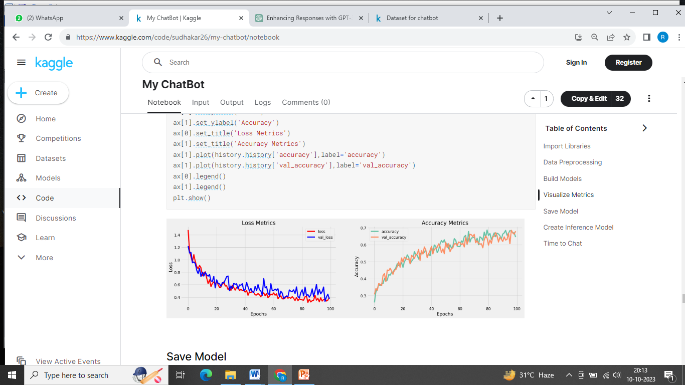

**Save Model**

**IN[17]:**

model.load_weights('ckpt')

model.save('models',save_format='tf')

**IN[18]:**

for idx,i in enumerate(model.layers):

print('Encoder layers:' if idx==0 else 'Decoder layers: ')

for j in i.layers:

print(j)

print('---------------------')

Encoder layers:

<keras.layers.core.embedding.Embedding object at 0x782084b9d190>

<keras.layers.normalization.layer_normalization.LayerNormalization object at 0x7820e56f1b90>

<keras.layers.rnn.lstm.LSTM object at 0x7820841bd650>

---------------------

Decoder layers:

<keras.layers.core.embedding.Embedding object at 0x78207c258590>

<keras.layers.normalization.layer_normalization.LayerNormalization object at 0x78207c78bd10>

<keras.layers.rnn.lstm.LSTM object at 0x78207c258a10>

<keras.layers.core.dense.Dense object at 0x78207c2636d0>

---------------------

**Create Inference Model**

**IN[19]:**

class ChatBot(tf.keras.models.Model):

def __init__(self,base_encoder,base_decoder,*args,**kwargs):

super().__init__(*args,**kwargs)

self.encoder,self.decoder=self.build_inference_model(base_encoder,base_decoder)

def build_inference_model(self,base_encoder,base_decoder):

encoder_inputs=tf.keras.Input(shape=(None,))

x=base_encoder.layers[0](encoder_inputs)

x=base_encoder.layers[1](x)

x,encoder_state_h,encoder_state_c=base_encoder.layers[2](x)

encoder=tf.keras.models.Model(inputs=encoder_inputs,outputs=[encoder_state_h,encoder_state_c],name='chatbot_encoder')

decoder_input_state_h=tf.keras.Input(shape=(lstm_cells,))

decoder_input_state_c=tf.keras.Input(shape=(lstm_cells,))

decoder_inputs=tf.keras.Input(shape=(None,))

x=base_decoder.layers[0](decoder_inputs)

x=base_encoder.layers[1](x)

x,decoder_state_h,decoder_state_c=base_decoder.layers[2](x,initial_state=[decoder_input_state_h,decoder_input_state_c])

decoder_outputs=base_decoder.layers[-1](x)

decoder=tf.keras.models.Model(

inputs=[decoder_inputs,[decoder_input_state_h,decoder_input_state_c]],

outputs=[decoder_outputs,[decoder_state_h,decoder_state_c]],name='chatbot_decoder'

)

return encoder,decoder

def summary(self):

self.encoder.summary()

self.decoder.summary()

def softmax(self,z):

return np.exp(z)/sum(np.exp(z))

def sample(self,conditional_probability,temperature=0.5):

conditional_probability = np.asarray(conditional_probability).astype("float64")

conditional_probability = np.log(conditional_probability) / temperature

reweighted_conditional_probability = self.softmax(conditional_probability)

probas = np.random.multinomial(1, reweighted_conditional_probability, 1)

return np.argmax(probas)

def preprocess(self,text):

text=clean_text(text)

seq=np.zeros((1,max_sequence_length),dtype=np.int32)

for i,word in enumerate(text.split()):

seq[:,i]=sequences2ids(word).numpy()[0]

return seq

def postprocess(self,text):

text=re.sub(' - ','-',text.lower())

text=re.sub(' [.] ','. ',text)

text=re.sub(' [1] ','1',text)

text=re.sub(' [2] ','2',text)

text=re.sub(' [3] ','3',text)

text=re.sub(' [4] ','4',text)

text=re.sub(' [5] ','5',text)

text=re.sub(' [6] ','6',text)

text=re.sub(' [7] ','7',text)

text=re.sub(' [8] ','8',text)

text=re.sub(' [9] ','9',text)

text=re.sub(' [0] ','0',text)

text=re.sub(' [,] ',', ',text)

text=re.sub(' [?] ','? ',text)

text=re.sub(' [!] ','! ',text)

text=re.sub(' [$] ','$ ',text)

text=re.sub(' [&] ','& ',text)

text=re.sub(' [/] ','/ ',text)

text=re.sub(' [:] ',': ',text)

text=re.sub(' [;] ','; ',text)

text=re.sub(' [*] ','* ',text)

text=re.sub(' [\'] ','\'',text)

text=re.sub(' [\"] ','\"',text)

return text

def call(self,text,config=None):

input_seq=self.preprocess(text)

states=self.encoder(input_seq,training=False)

target_seq=np.zeros((1,1))

target_seq[:,:]=sequences2ids(['<start>']).numpy()[0][0]

stop_condition=False

decoded=[]

while not stop_condition:

decoder_outputs,new_states=self.decoder([target_seq,states],training=False)

# index=tf.argmax(decoder_outputs[:,-1,:],axis=-1).numpy().item()

index=self.sample(decoder_outputs[0,0,:]).item()

word=ids2sequences([index])

if word=='<end> ' or len(decoded)>=max_sequence_length:

stop_condition=True

else:

decoded.append(index)

target_seq=np.zeros((1,1))

target_seq[:,:]=index

states=new_states

return self.postprocess(ids2sequences(decoded))

chatbot=ChatBot(model.encoder,model.decoder,name='chatbot')

chatbot.summary()

Model: "chatbot_encoder"

_________________________________________________________________

Layer (type) Output Shape Param #

=================================================================

input_1 (InputLayer) [(None, None)] 0

encoder_embedding (Embeddin (None, None, 256) 625408

g)

layer_normalization (LayerN (None, None, 256) 512

ormalization)

encoder_lstm (LSTM) [(None, None, 256), 525312

(None, 256),

(None, 256)]

=================================================================

Total params: 1,151,232

Trainable params: 1,151,232

Non-trainable params: 0

_________________________________________________________________

Model: "chatbot_decoder"

__________________________________________________________________________________________________

Layer (type) Output Shape Param # Connected to

==================================================================================================

input_4 (InputLayer) [(None, None)] 0 []

decoder_embedding (Embedding) (None, None, 256) 625408 ['input_4[0][0]']

layer_normalization (LayerNorm (None, None, 256) 512 ['decoder_embedding[0][0]']

alization)

input_2 (InputLayer) [(None, 256)] 0 []

input_3 (InputLayer) [(None, 256)] 0 []

decoder_lstm (LSTM) [(None, None, 256), 525312 ['layer_normalization[1][0]',

(None, 256), 'input_2[0][0]',

(None, 256)] 'input_3[0][0]']

decoder_dense (Dense) (None, None, 2443) 627851 ['decoder_lstm[0][0]']

==================================================================================================

Total params: 1,779,083

Trainable params: 1,779,083

Non-trainable params: 0

__________________________________________________________________________________________________

**IN[20]:**

tf.keras.utils.plot_model(chatbot.encoder,to_file='encoder.png',show_shapes=True,show_layer_activations=True)

**OU[20]:**

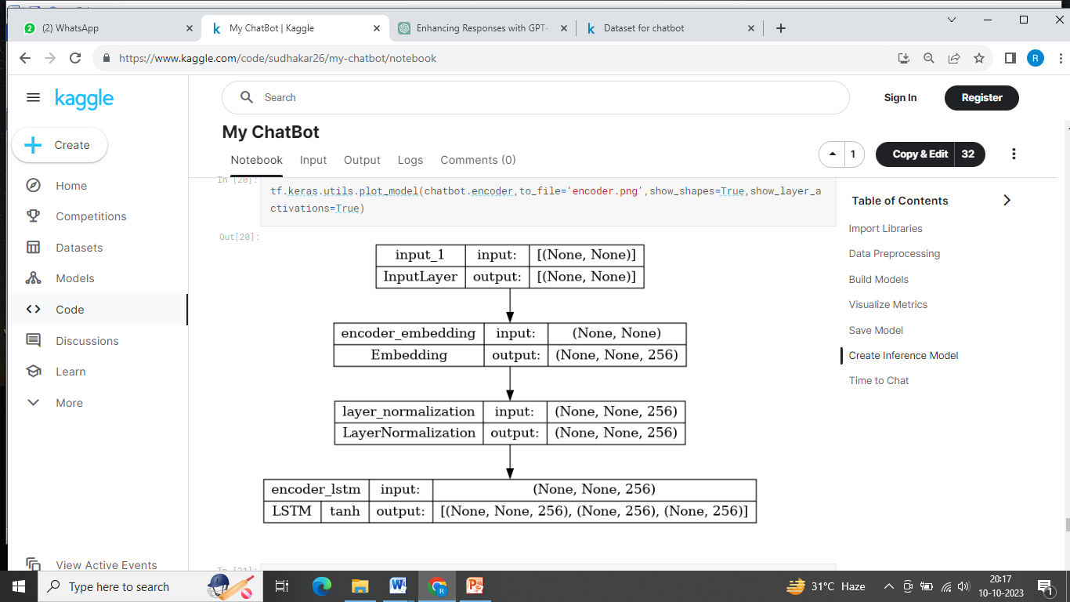

**IN[21]:**

tf.keras.utils.plot_model(chatbot.decoder,to_file='decoder.png',show_shapes=True,show_layer_activations=True)

**OU[21]:**

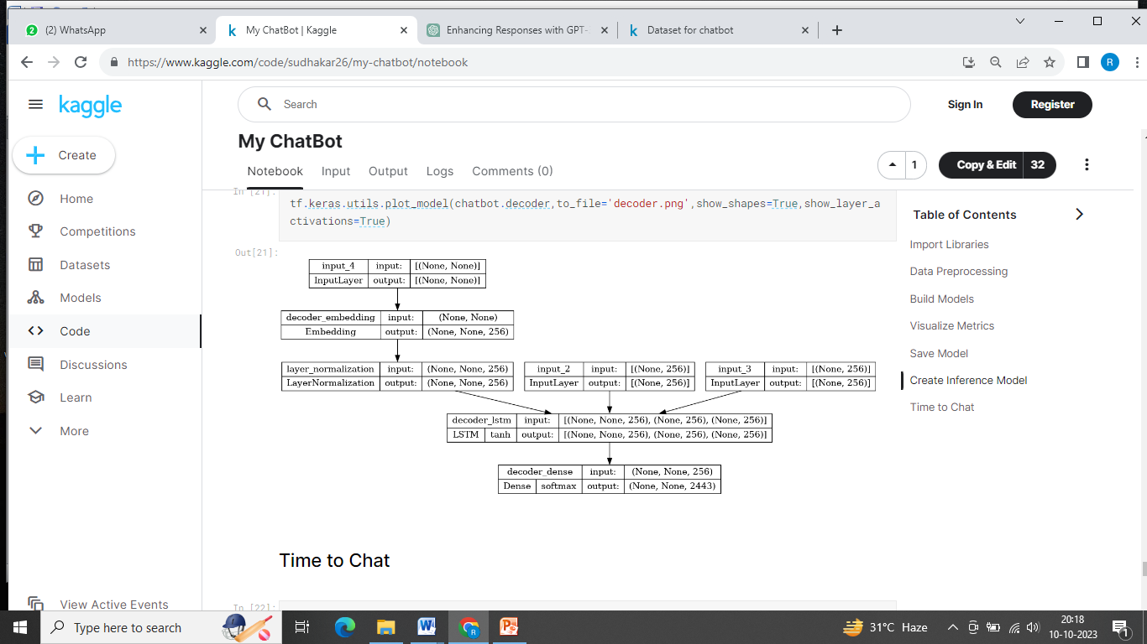

**Time to Chat**

**IN[22]:**

def print_conversation(texts):

for text in texts:

print(f'You: {text}')

print(f'Bot: {chatbot(text)}')

print('========================')

**IN[23]:**

print_conversation([

'hi',

'do yo know me?',

'what is your name?',

'you are bot?',

'hi, how are you doing?',

"i'm pretty good. thanks for asking.",

"Don't ever be in a hurry",

'''I'm gonna put some dirt in your eye ''',

'''You're trash ''',

'''I've read all your research on nano-technology ''',

'''You want forgiveness? Get religion''',

'''While you're using the bathroom, i'll order some food.''',

'''Wow! that's terrible.''',

'''We'll be here forever.''',

'''I need something that's reliable.''',

'''A speeding car ran a red light, killing the girl.''',

'''Tomorrow we'll have rice and fish for lunch.''',

'''I like this restaurant because they give you free bread.'''

])

You: hi

Bot: i have to go to the bathroom.

========================

You: do yo know me?

Bot: yes, it's too close to the other.

========================

You: what is your name?

Bot: i have to walk the house.

========================

You: you are bot?

Bot: no, i have. all my life.

========================

You: hi, how are you doing?

Bot: i'm going to be a teacher.

========================

You: i'm pretty good. thanks for asking.

Bot: no problem. i'll have to give you the english assignments from my mind.

========================

You: Don't ever be in a hurry

Bot: it's not a great.

========================

You: I'm gonna put some dirt in your eye

Bot: that's a good idea.

========================

You: You're trash

Bot: the tv news is reporting a bank robbery.

========================

You: I've read all your research on nano-technology

Bot: it's the weather. i've gone around the world.

========================

You: You want forgiveness? Get religion

Bot: no, i'll be my.

========================

You: While you're using the bathroom, i'll order some food.

Bot: don't order for me. i've been a cheater.

========================

You: Wow! that's terrible.

Bot: never park your car under the house.

========================

You: We'll be here forever.

Bot: we'll be there in half an hour.

========================

You: I need something that's reliable.

Bot: you need a car with low mileage.

========================

You: A speeding car ran a red light, killing the girl.

Bot: what happened?

========================

You: Tomorrow we'll have rice and fish for lunch.

Bot: i'll make a sandwich.

========================

You: I like this restaurant because they give you free bread.

Bot: well, i think that's a good idea.

========================

**Conclusion:**

In Phase 2 of our project, our exploration of advanced techniques leveraging pre-trained language models like GPT-3, we've unveiled a new realm of possibilities for improving the quality and effectiveness of responses within our chatbot system.